Chirnsyde Primary School
Relationships and Behaviour Policy
2020

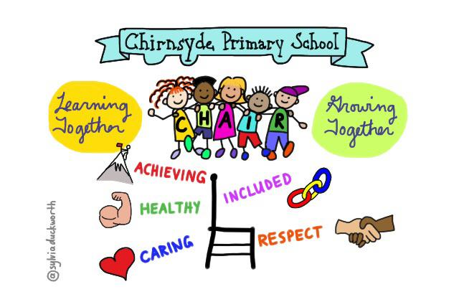

Children's wellbeing is at the heart of Getting it Right for Every Child. This means focusing on the wellbeing of every child to ensure they are safe, healthy, achieving, nurtured, active, respected, responsible and included
A positive school ethos and culture is essential to developing good relationships and positive behaviour in the classroom, playground and wider community
The Scottish Government tell us
‘A culture where children and young people feel included, respected, safe and secure and where their achievements and contributions are valued and celebrated is essential to the development of good relationships. In order to create this environment for effective learning and teaching there should be a shared understanding of wellbeing underpinned by children’s rights and a focus on positive relationships across the whole school community’.
How do we do this at Chirnsyde?
Everything we do at Chirnsyde starts with our Values; they underpin everything we do - our Values are how we behave. When we role model relationships, we do so, using our values and when we help our pupils when they are not getting on or treating each other well, we use our values to explain this.
Our School Values are
Caring – this means we care for each other; we think about how our behaviour and actions affect each other. We care about our school, our community and our world.
Healthy – this means we look after our physical and our mental health. The choices we make should not harm our or anyone else’s wellbeing.
Achieving – this means we work hard and do the best we can. We value effort and that people are sometimes better at some things than other things. We work in partnership with pupils, teachers and families.
Included – this means we want to see everyone have the chance to be involved and to have a voice in what happens at Chirnsyde. We will look to make sure we all feel part of the community we live in and everyone’s Rights are respected.
Respect – this means we value each other; we treat each other with kindness and concern. We will stand up to prejudice at Chirnsyde and do not like words or actions that hurt people because of who they are or where they come from.
Our motto is Learning together, Growing Together.
Our vision at Chirnsyde is to create a safe, healthy, happy and inclusive school where everyone feels valued and work together to promote lifelong learning
Children’s Rights
Our role is to promote and protect children’s Rights. Our children have the right to be safe, to be listened to and have a say in what happens in their life. Positive relationships across the school are supported by attitudes and actions that respect the rights of others. Our staff are trained in understanding children’s Rights and they are a part of our Values. Every year we raise awareness of the UNCRC through classroom and whole school work.
We link this work to our work on relationships, behaviour, on mental health and wellbeing, and to anti-bullying and equality and diversity.
Participation
As part of our commitment to children’s Rights, we ensure that our pupils have a voice at Chirnsyde. They are involved in policy development across the school and have helped write several polices including Anti-Bullying and Equality and Diversity.
We are committed in the coming year to reviewing and re-establishing a series of pupil forums based on their priorities
Our Approach to Relationships and Behaviour
At Chirnsyde we believe in taking a blended approach and we do not rely on one singe method or model to do this. We have a rage of approaches and we seek to use the most appropriate one for each situation. We put the needs of our pupils first and will always see them as individuals that are art of a family and a community.
The key at Chirnsyde is that all of our work and whatever approach we use, is underpinned by our values and that relationships are protective and vitally important for us to succeed as a school.
Relationships come first, the building of trusted, predictable and consistent relationships between adults and children is what we aim to do at Chirnsyde.
We use a Nurture Approach, a Restorative Approach, A Trauma-Informed Approach, we take a Values-Based Approach to relationships and behaviour at Chirnsyde and these all blend into a broad and child-centred approach that values relationships, respect and learning.
We also have an approach we use to deal with bullying, discrimination and prejudice that forms part of what we do at Chirnsyde.
This illustrates how or approach should lead to better relationships and behaviour at Chirnsyde -
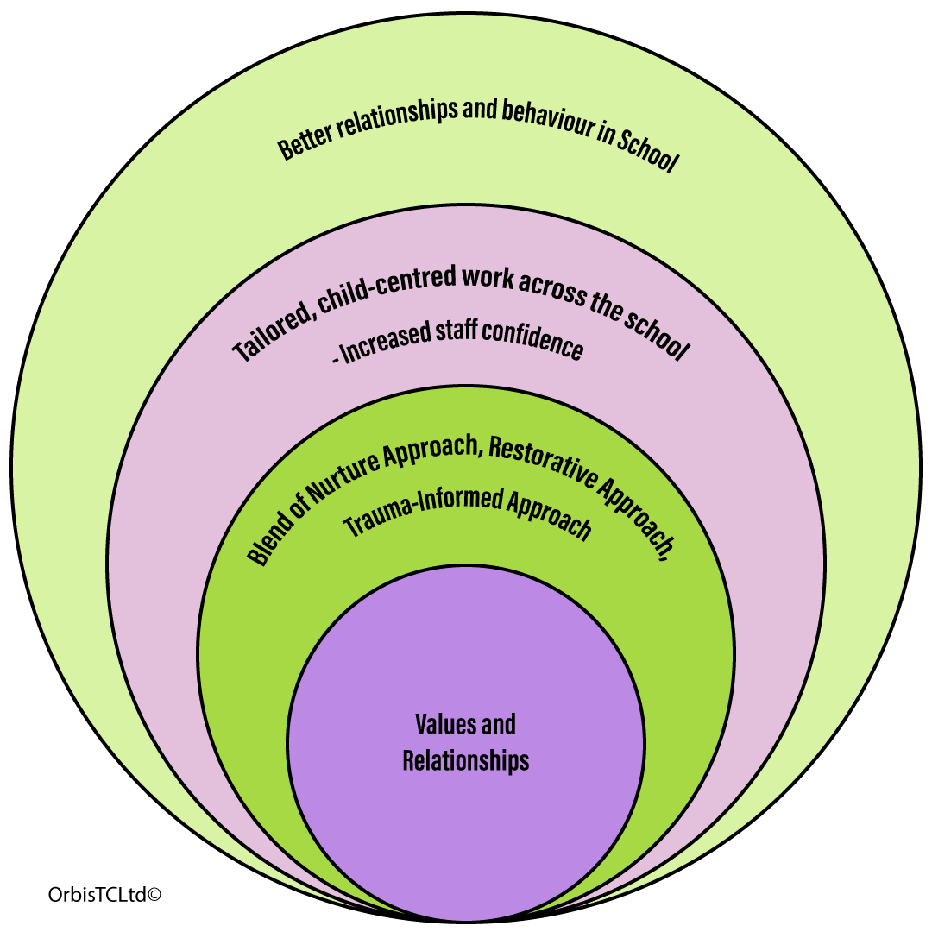

Nurture Approach
In Glasgow we aim to ensure that all our schools and nurseries are places in which children feel welcomed, nurtured and secure. We want children and their families to feel that their needs are understood and met in our schools and nurseries. To do this we work to help all staff continually develop nurturing approaches so that they can meet the needs of all children
A nurturing approach recognises that positive relationships are central to both learning and wellbeing. All staff fully understand the principles of nurture and use this understanding to ensure that children feel safe and respected and can grow and learn.
A key aspect of a nurturing approach is an understanding of attachment theory and how early experiences can have a significant impact on development.
There are 6 Principles to a Nurturing Approach
- Children’s learning is understood developmentally
- The classroom offers a safe base
- The importance of nurture for the development of wellbeing
- Language is a vital means of communication
- All behaviour is communication
- The importance of transition in children’s lives
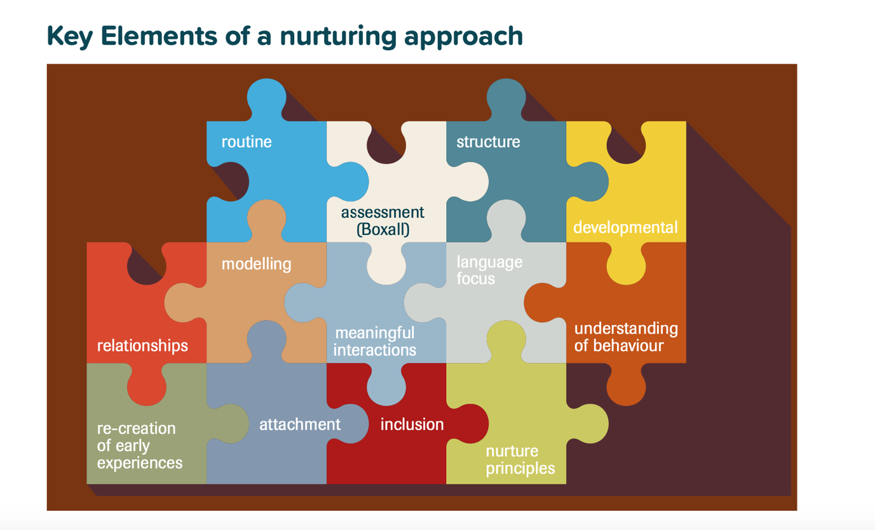

Restorative Approach
Restorative approaches can change the emotional atmosphere in a school and lead to more positive relationships between pupils and between pupils and staff. They are defined as are defined as restoring good relationships when there has been conflict or harm and developing school ethos, policies and procedures to reduce the possibility of such conflict and harm arising.
The focus on repairing relationships reflects the values of Chirnsyde, it does not mean actions are consequence free, but we seek to model and teach children the skills to manage relationships.
A restorative approach may include having a ‘restorative conversation’. These conversations may happen during the school day and practitioners will use restorative language and questions to allow children and young people to understand the impact of their behaviours.
More serious incidents may require practitioners to hold a formal meeting and involve parents or families where appropriate. Examples of questions used in a formal meeting include:
- What happened?
- What were your thoughts at the time?
- What have been your thoughts since?
- Who has been affected by what happened?
- How have they been affected?
- What do you need to happen now?

Restorative practices work well as part of a blended approach and should be used appropriately. There may be occasions where, for example some bullying, or prejudice-based behaviour should not see the children involved sit together to discuss what happened. We will be mindful of the dynamics of situations and balance the risk where someone may be fearful, worried or anxious about the impact of a face to face discussion.
Trauma-Informed Approach
The impact of trauma, stress, attachment and Adverse Childhood Experiences is being increasingly better understood and assimilated into approaches to managing behaviour.
Experiences such as neglect, abuse, poverty, loss and violence can result in children developing coping strategies to manage the difficult feelings this can lead to. These coping strategies can be challenging, difficult to manage, harmful to themselves and others as well as distressing to deal with.
Our aim when dealing with this distressing behaviour is to help children and young people to learn new ways to respond to difficult feelings, to help learn new coping mechanisms for their difficult feelings.
Our approach to dealing with challenging and distressing behaviour is based on us reframing our understanding of behaviour. We see behaviour as an indicator of stress. We recognise that when behaviour is escalating and a child is becoming distresses and anxious, their stress levels are increasing. Our approach is to reduce their stress levels and then we can deal effectively with behaviour.
This illustration indicates the increase in stress levels and the impact it can have on behaviour and helps us focus our interventions appropriately.
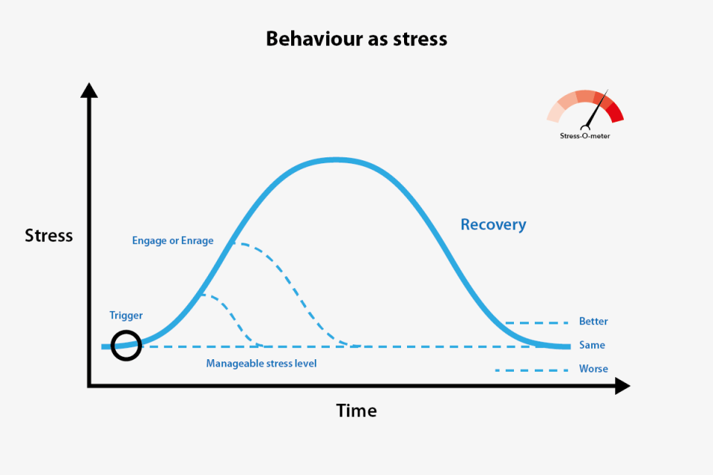
Some of the children and young people who come to our school will have experienced or are still experiencing traumatic events. Children that have had Adverse Childhood Experiences, children who have suffered violence, neglect, loss, abuse and have attachment issues will have developed ways to respond to the feelings these traumas cause, and these can persist and affect them even after these events have happened.
These experiences can lead to children being hyper sensitive and reactive. They may struggle in groups or changes in routine. Changes can trigger an increase in stress levels.
Some of this trauma will impact on a child for a very long time and our focus needs to be on helping them learn ways to cope with these traumas.
When we focus on reducing stress, we are teaching new coping mechanisms for difficult feelings. We still deal with their behaviour and the impact it has had; we reduce stress levels first then deal with that.
Responding to distressing behaviour
Children and young people will operate with a manageable level of stress, where they can cope with the routine and with others. For stress levels to increase, something will ‘trigger’ this. A change in routine, being told ‘no’, a threat, a mistake. These triggers will lead to a feeling and in response to this feeling, stress levels begin to increase.
There will be some signs that suggest stress is increasing, there will be physical changes, face colour, clenched fists, and teeth, agitation, breathing changes and so on.
When something has triggered an increase in stress and a child’s behaviour begins to show signs of changing, or escalating, we can do one of two things, we can engage with this person, or we can enrage them.

Natural Consequences
We have an approach at Chirnsyde that seeks to teach our children about natural consequences. Our aim is to link behaviour to actions. This does not mean behaviour is consequence free, some consequences can be very serious.
The goal is to help pupils learn that their behaviour has an impact on themselves, others, and their environments
This can range from if we break something, we do not have it to use, if we make a mess, we can help clean it, if we hurt someone’s feeling, we make amends. If someone is aggressive or hurts someone outside, they may have to come inside as a result.
This approach helps children understand the impact of kindness on others.
Review
This policy will be reviewed in 2023
June 2020

