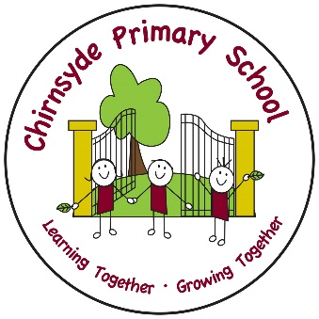
October Newsletter

Parents Evening
We look forward to meeting parents/carers tomorrow in the school hall. You should have had an appointment time sent home in children’s bags. There will be no creche service so please make alternative childcare arrangements if possible.

Halloween
We are having our Halloween Parties for the children on 28th October. Children can come to school in costume but should be warm enough to play outside. Please be aware that children must not wear scary masks, scary costumes or weapons as this can scare our younger children. Can you assure that your child’s costume is age appropriate i.e. 12yrs and under. We will be providing the children with some snacks and juice.
Children can bring a carved pumpkin into school that day to help decorate the hall for our parties.

Snacks
We are a health promoting school and appreciate your support when encouraging children to bring healthy snacks. Please avoid sugary snacks as these can prevent children from concentrating on their learning in class.
We are also a NUT FREE school as we have a few children who have serious nut allergies. This includes chocolate spreads such as Nutella.

Holidays
14th October – Inset day (staff only in school)
17th – 21st October – Holiday. Pupils and staff return on Monday 24th October.
22nd December – school closes at 2:30pm and children return on Wednesday 4th January.

